Technical Documents for Couplers

- Supply Quantities
Not defined in this document
- Delivery Period
Not defined in this document

- Scope of supply（A set of coupler）
Each set shall be composed by next items.

Name | Qty
Type 13B coupler (with knuckle and internal parts) | 2
MT-2 Draft Gear | 2
Type 13B yoke | 2
follower | 2
coupler yoke key | 2
Yoke Key bolt assy | 2
Acting rod | 2
Rod support | 2
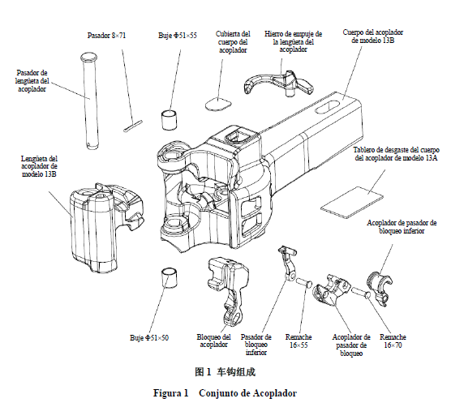
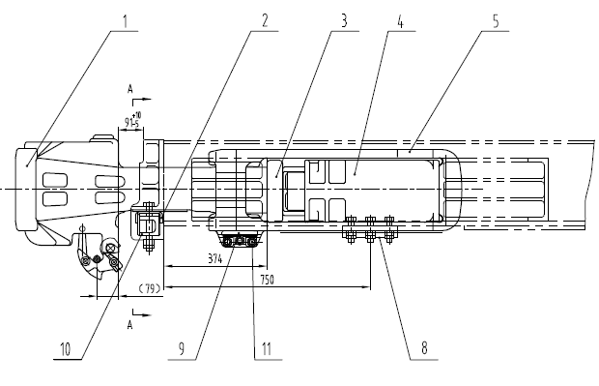
- 13B Coupler with knuckle
3-Follower
4-MT-2 draft gear
5-13B yoke
9-coupler yoke key and yoke key boody assy
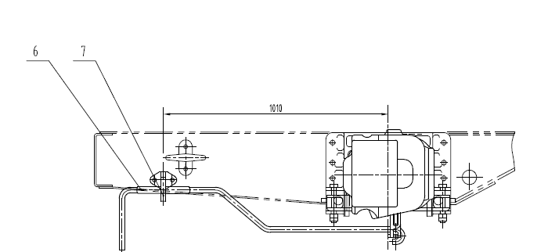
6- Acting rod
9-rod support

- Packing and Shipment

A set of coupler placed in a plywood or wooden cases, the bottom of boxes use the tray structure , can be suitable for forklift truck transport. The boxes will be shipment by 20 ft container.

- Rules and tests
Coupler must satisfy AAR-A10 contour.
Coupler, followers, jokes shall satisfy standard TB/T 456-2008. It will be designed with steel class E or higher. In case TB/T 3334-2013 indicate higher request than TB/T 456-2008, then first (hardest) one must be followed.
MT-2 Draft gear shall satisfy standard TBT 3334-2013.

Test shall be carried out according TBT 2399-1993
- Packing

Each set of coupler placed in a plywood or wooden cases, the bottom of boxes use the tray structure , can be suitable for forklift truck transport. The boxes will be shipment by 20 ft container.

- Coupler Drawings and coupler´s socket dimensions
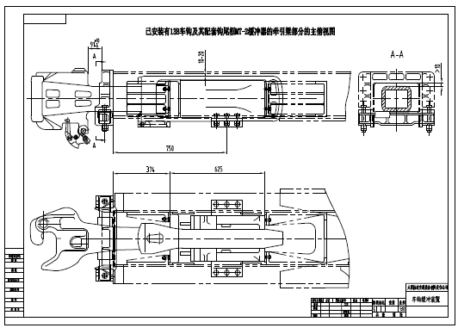
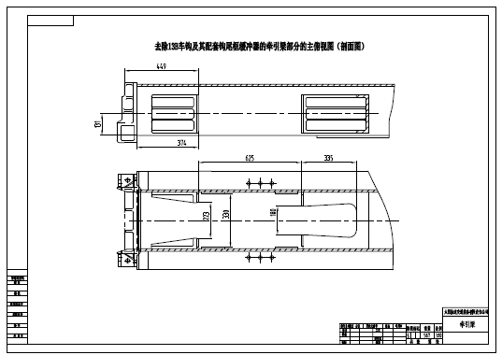
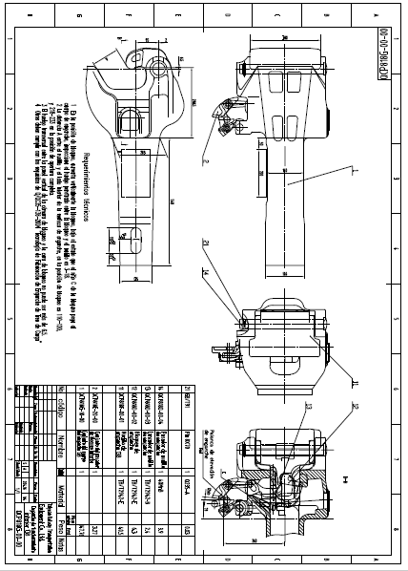

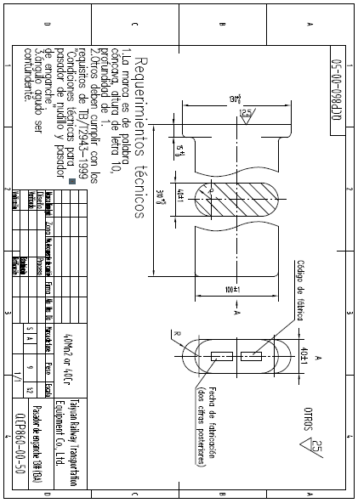

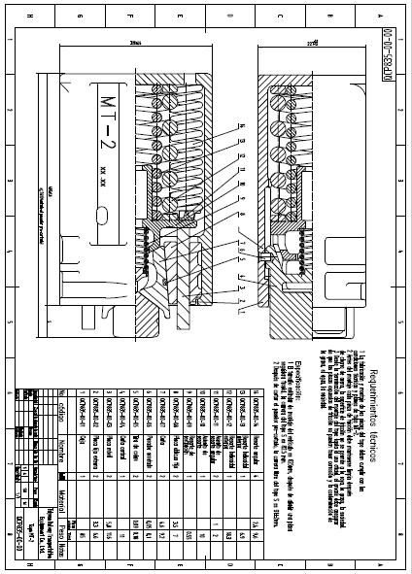

The Principal’s Representative(BCYL):

Signature:

Date:

